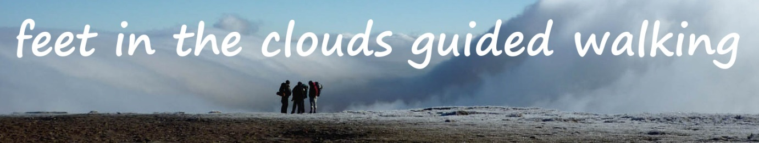
FEET IN THE CLOUDS - BOOKING FORM
Thank you for booking with Feet in the Clouds!
Please complete this form (one for each person) and return to us – see bottom of page for contact and payment details.
Name and date of walk/s you are attending
Name

Postal address
Email address

Landline

Mobile

Medical conditions and medications (see info below)
Payment method: Paypal/bank or cheque?
Paypal/bank transaction reference if applicable

Declaration:
I confirm I am fit and able to complete a walk of this nature as described on www.feetintheclouds.co.uk, and have read the essential information below.
I understand that while Feet in the Clouds leaders will do their best to minimise any inherent risks of hiking, I am responsible for my own actions.
Signed (by a parent or guardian if under 18):……………………………………………………………………………….
Mailing list
We’d love to keep you updated by email on upcoming walks, new walks, our latest adventures and other bits and pieces we think you’ll enjoy. We’ll never share your contact details with anybody else.
Please state NO if you’d rather not be on the list ………………………………
Returning this form
Please complete and return this form via email to info@feetintheclouds.co.uk or print & post to: Feet in the Clouds, Whitbeck Farm, Lofthouse, Harrogate, North Yorkshire, HG3 5SF.
If paying by cheque (as long as it’s at least 2 weeks before the event), please make payable to ‘Angela Harker’ and enclose with this form.
ESSENTIAL INFORMATION
We’ll do our best to make sure you have a great day out, but there are a few things we’d like to ask in return to make sure everything runs smoothly, and most importantly safely.
Please ensure you’ve read and understood the following before booking:
Equipment
The weather and temperature can change very quickly during the day, especially on the moors and fells. In the hills, temperatures and conditions can be dramatically different to those in the valley bottoms – it’s not uncommon to get 3 or 4 seasons in one day!
Please bring all of the following items, regardless of weather and time of year:
- Waterproof jacket and trousers
- Fleece or other spare warm layer
- Base layer (eg. synthetic long sleeved top or t-shirt next to skin – not cotton)
- Sturdy, supportive walking boots (worn in before the walk!)
- Hat, gloves and scarf (plus spares on particularly cold/windy days)
- Sunhat, sun cream & sunglasses
- Water: min 2 litres for long walks and hot days
- Packed lunch
- High energy snacks
- Personal first aid kit (personal medications/painkillers, blister plasters etc. – please note we can’t give out any medications)
Please don’t:
- Wear cotton base layers/jeans – these absorb moisture easily and don’t dry so damp or sweaty conditions will cause chafing and you will feel the cold every time you stop.
- Rely on refreshments being available for purchase en route – it’s vital you have enough energy to keep you going if snack vans etc. are closed.
Safety issues
Your leader’s role is to ensure you have an enjoyable and safe day out. They will be qualified, insured and experienced, so please listen to and follow any instructions given.
Terrain covered may include boggy, uneven or steep ground, all of which can require even more care when wet. Individual walk descriptions will highlight anything you need to be aware of but if you are concerned about anything, please do give us a shout. Don’t forget all our walks are risk assessed and your leader is there to support you.
However, please be aware that any outdoor activity will hold unavoidable risks and that Feet in the Clouds will not be liable for any accident, loss or injury unless it is the result of negligence on our part.
Amendments and cancellations
Your guide will retain the discretion to amend or cancel a walk for reasons of safety, enjoyment or group ability, or refuse participation to any guest who doesn’t have the required clothing/equipment, isn’t deemed fit to participate or for any reason compromises the safety or enjoyment of the walk for others.
If you have any concerns in advance regarding equipment/abilities etc., just give us a shout and we’ll gladly offer advice and suggestions.
If weather conditions prevent a walk from going ahead, an alternative will be offered wherever possible, eg. a low level valley walk may be offered instead of a high fell walk if gales are forecast.
If the walk is cancelled by Feet in the Clouds (either in advance or on the day before the walk starts) then a full refund or the option to transfer to another walk will be offered.
If a walk is cut short after it has commenced, eg. due to deteriorating weather or injury, a refund will not be offered as the event is considered to have taken place. The decision to end a walk lies with the leader.
If you can’t make a walk, we’ll offer a refund up to two weeks in advance of the walk.
Medical declarations
Please provide any medical information and requirements on the booking form or have a quiet word with your leader on the day. These are not intended to exclude anybody but they do help us to help you, for example tailoring eating times if you are diabetic, or being aware of emergency medications you carry eg. inhalers for asthma attacks. Information given is of course confidential.
Views
Needless to say, while the views are usually as spectacular as we’ve described, they are nonetheless subject to good weather conditions! But don’t worry – even if the cloud’s down, there’s often plenty to see en route and it all adds to the sense of adventure!
What the price includes
- Guided walking with a qualified leader to handle all the route planning, navigating and other crucial stuff
- Local knowledge and a greater insight into an area and its community than the guidebooks might provide
- Privately organised transport on linear walks (this will be stated in walk description)
What the price doesn’t include
- Transport to and from the starting point, car park fees where applicable
- Public transport on linear routes (see walk description for information)
- Refreshments
Age requirements
Children under 18 are welcome on Feet in the Clouds walks, but they must be accompanied by an adult over the age of 18, and we’ll trust your judgement regarding their ability to complete the walk. Please refer to individual walk descriptions for specific information on walk difficulties, or contact us if you have any questions.
Dogs
Dogs are welcome on most of our walks on short leads, but please check with us as some of our days cross restricted areas including sensitive ground nesting bird habitats. Please be aware nearly all our walks will bring us into contact with cows and calves.
Data Protection
Your personal details and information will never be shared with anybody else, nor will they be used by us for any reason other than those for which you have provided them.

